***PAAREES PERFUMES***

***Christian Diors***

***FOR UNISEX***

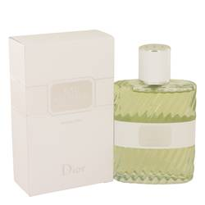

# *Eau Sauvage Cologne*

***Description:***

Eau Sauvage Cologne by Christian Dior Cologne. This Eau Sauvage Cologne is a 2015 reimagining of the iconic original release of the fragrance from 1966. This long-lasting scent blossoms forth with top notes of Calabrian bergamot, tangy grapefruit and bright, sweet mandarin orange. The middle notes include hints of pink pepper, galbanum, hedione, and petitgrain, which work together to create an experience that’s spicy, sweet and earthy all at the same time. Vetiver serves as the base note of this elegant fragrance, and provides a smooth, mellow closing that any wearer is sure to enjoy.  
  
Christian Dior is a well-known presence in the global fashion industry, and for good reason. The brand – and the man behind it – have been in business since 1947, when it introduced a radically different style that helped to define post-Wwii fashion and redefine Paris as the fashion capital of the globe. The brand launched its first fragrance the very year it was founded, and traditionally launches a new scent to match each new look it produces.